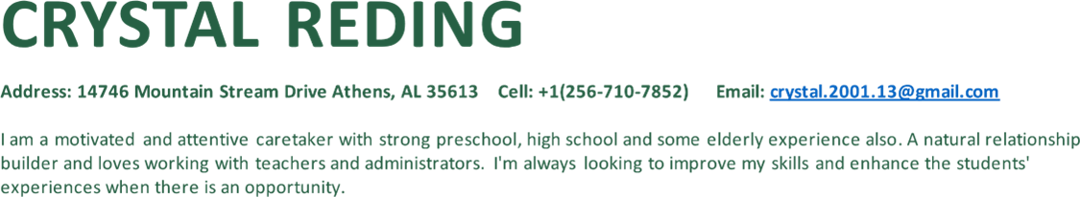

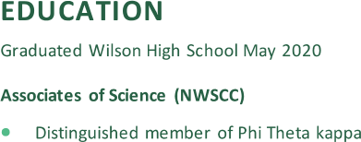

Experience
Teacher's Aide (AAA Classroom) | Brooks Elementary School | Killen, AL
August 2024 – Present

Teacher's Aide (AAA Classroom) | Lauderdale County High School | Rogersville, AL
August 2023 – May 2024
- Help with instruction
- Being there for the kids and their needs
- Being an encourager along with loving and caring
- Help feed the kids
- Change diapers
- Clean when needed

Ready to Wear Sales Associate | Dillard's | Florence, AL
July 2022 – March 2025
- Having great customer service skills
- Communication skills
- Capable of putting out stock and keeping the area organized
- Handling money
- Multitasking

Customer Service Supervisor | Ollies Bargain Outlet| Florence, AL
August 2020 – July 2022
- Having Great Customer service
- Be able to handle tough situations
- Open and close store
- Be able to handle money (count tills)
- Unloaded trucks
- Put stock out
- Cashiering

Resident Assistant | Mitchell-Hollingsworth Nursing and Rehabilitation Center | Florence, AL
September 2019 – August 2020
- Take care of the residents’ needs
- Help CNAs with tasks
- Changed bedding
- Keep resident's company
- Transport resident to and from activities

Cashier/ Office Manager | Foodland | Florence, AL
June 2018 – September 2019
- Open and close the store
- Responsible for being a leader
- Great customer service skills
- Count tills
- Help customers

Caretaker | Grandmother | Killen, AL
May 2012 – February 2014
- Bathe her everyday
- Change diapers
- Clean bedding
- Administer her medicine
- Feed her every meal
- Keep her company

Skills
- Helping with lessons  - Aiding in physical demands such as changing diapers, preparing meals, transporting students  - Caregiving  - Communication | - Mentoring and encouraging students/ adults  - Leadership  - Management  - Cashier  - Counting

